Kapinara Primary School
How to Book a Parent–Teacher Conference (Compass)
When Parent–Teacher Conferences open, families will receive a notification in Compass advising that bookings are available.
Follow the steps below to book a conference with your child’s teacher.

Step 1 – Log in to Compass
Open the Compass App on your phone or log in through the Compass website.

Step 2 – Open the Conference Booking
When bookings are available, you will see a notification on your Compass dashboard.
Click this notification to open the Parent–Teacher Conference event.

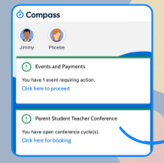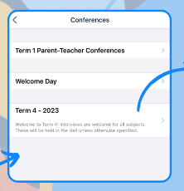

Step 3 – Read the School Message
You will see a welcome message from Kapinara Primary School with details about the conference sessions.
Click OK / Done to continue.

Step 4 – Select Your Child
If you have more than one child at Kapinara, choose the student you wish to book a conference for.

Step 5 – Choose the Teacher
Select the teacher or class you would like to meet with.
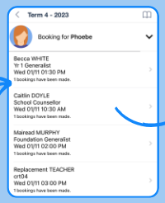

Step 6 – Choose a Time
A schedule will appear showing available appointment times.
Click on an available time slot to make your booking.

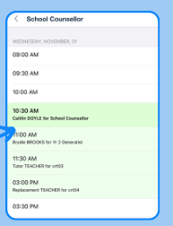

Step 7 – Confirm Your Booking
Confirm the appointment details to finalise your booking.
Your booking will then appear in your Compass schedule as confirmation.

