Attendance Policy and Procedures
Rationale
Kapinara PS is committed to promoting the Department of Education’s key message: 'Every Day Matters’. We believe that attendance at school is the responsibility of everyone in the community, and are dedicated to monitoring, communicating and implementing strategies to improve students’ attendance via a focused and strategic approach.

The likelihood of success in learning is strongly linked to regular attendance and appropriate participation in educational programs. It is crucial that students develop habits of regular attendance at an early age, even from the time they are enrolled in a preschool setting. Children who have poor patterns of attendance are at risk of not achieving their educational, social, or psychological potential and are disadvantaged in the quality of choices they are able to make in later life.

Research has shown that missing half a day of school each week leads to an attendance rate of less than 90% and equates to one month of missed learning each year. If children miss half a day of school each week between Pre-primary and Year 10, they will miss almost one full year of learning.

Procedures
We recognise that there are many factors that impede regular attendance at school, and we work with students and families to understand those factors and actively support engagement with the school. We have procedures in place to identify students at risk and communicate clearly and effectively with parents/carers.

We monitor the attendance of all students and implement appropriate strategies to maintain or restore attendance according to the following categories:

Category | % Range | Likely Outcomes
Regular | 90-100% | Best chance of achieving potential
Indicated | 80-89% | Decreased chance of achieving potential
Moderate at risk | 60-79% | Limited chance to reach potential
Severe at risk | 0-59% | Unlikely to reach potential

Daily Attendance Monitoring
Teaching staff will record each student’s attendance in Compass twice daily, at 9am and 12pm. Relief Teachers are provided access to Compass for the roll for each class that they relieve during the day. Students who are late to class must supply the teacher with a late note from the office.

Kapinara PS will record a student as:
- Present for a half day when the student has attended at least two hours of instruction.
- Attending if they are on a school-approved activity.

Kapinara PS will contact parents/carers via Compass link where possible if a student has been marked absent during any period of the day and no contact has been made with Kapinara PS.

Parents can notify Kapinara PS of absences via the COMPASS Portal to add attendance notes.

Illness and Injury
Where there is the possibility of an extended absence (more than a week), parents/carers should liaise with the School Officer. Where a student has an ongoing mental or physical illness and/or health care need which may impact their ability to attend school, they may be eligible to access in-home education support.

Suspension
Students must continue to meet the requirements of their education program. Teachers may provide any student who is suspended for more than three days with educational instruction during the period of instruction.

Permission to Leave the School During the Day
Students who are required to leave Kapinara PS during the day must be accompanied by their parent/caregiver. Parents/caregivers are required to sign their child out when leaving and return via the front office. Early departure must also be recorded through Compass and identified with appropriate attendance code.

A student is not permitted to leave Kapinara PS site at any time during the day without permission. No student is allowed to be out of class without permission from a teacher.

Unauthorised vacations
The School Education Act 1999 does not allow principals to give permission for families to take holidays during the school term. As students are required to attend school every day that the school is open, time off for holidays is recorded as an absence.
We strongly encourage you to organise holidays during school holiday periods to make sure your child doesn’t miss out on school. School staff are not required to provide extra curriculum for student absenteeism due to recreational activities or extended leave.

Responsibilities

Administration responsibilities:
- Promote student attendance through clear statements of expectations and procedures.
- Develop and implement rigorous and effective systems to record and monitor attendance.
- Ensure that student attendance is recorded in every class, morning and afternoon.
- Maintain accurate attendance records in Compass and Student Attendance Reporting (SAR).
- Promptly process student transfers.
- Respond to parent requests for absences for vacations during the school term.
- Generate weekly email from Compass for all students with unexplained absences.
- Generate Compass emails to parents whose children are in the ‘indicated’, ‘moderate’ and ‘severe’ categories each term.
- Alongside classroom teachers, develop and monitor Individual Attendance Plans for students in the ‘moderate’ and ‘severe’ category.
- Provide ongoing support for students in the ‘moderate’ and ‘severe’ categories, as well as support for their teachers and parents/carers.
- Refer a student to the Principal when a student is deemed to be a ‘Student whose Whereabouts is Unknown’ (absent without explanation for more than 15 days).
- Invite families to Attendance Advisory Panels, as appropriate, and complete all required documentation.
- Consult with North Metropolitan Education Office when student attendance concerns continue despite intervention.

Teacher responsibilities:
- Promote and encourage attendance.
- Monitor and record each student’s attendance in Compass twice daily, by 9am and 12pm.
- Refer ongoing lateness to the Deputy Principal.
- Work with the Deputy Principal, student and parents/guardian to resolve the issue of lateness or ongoing absences.
- Refer parents/carers to administration to discuss requests for vacations during the school term.
- Provide parents/carers with guidance on alternative educational activities, websites, and apps to support their child’s learning during approved absences.

Student responsibilities:
- Always attend school, when well, and when the school is open for instruction.
- Arrive at school and attend all classes on time.
- Remain on the school premises during school time unless signed out by a parent/caregiver.
- Present at Front Office if arriving after 8:45am.
- Provide absentee notes or Medical Certificate to the Front Office or classroom teacher.
- Complete any work that is missed due to absences, if requested by the teacher.

Parent/Carer responsibilities:
- Always ensure their child attends school, when well, and when the school is open for instruction (see School Education Act, 1999).
- Promote and provide organisational support to their child to allow them to attend school and participate on all designated school days (unless complying with an arrangement under Section 24).
- Ensure their child is on time for school each day.
- Notify the school on the first day of their child’s absence.
- Notify the school in advance if an absence is planned.
- Support their child’s learning during approved prolonged absences through completion of educational activities.
- Work cooperatively and collaboratively with the school to develop and implement improvement strategies when their child’s attendance has been inconsistent.

- Work collaboratively with the school to support their child when returning to school after prolonged absences.
- Avoid scheduling family holidays during school terms. Whilst Kapinara PS respects that travel can be an educational experience it is important that it does not come at the cost of the child’s education. Parents are required to negotiate their child’s absence with the Principal prior to first day of non-attendance, otherwise the absence will be considered ‘unauthorised’ and recorded as such. Absence due to family vacation is deemed by the Education Department to be an unacceptable reason for a student’s absences from school.

Attendance Intervention Flowchart

Lesson Attendance Codes
There are 14 different codes used to record and monitor student attendance. Under the School Education Act 1999, principals are required to record whether a student ‘attended or participated in an educational program of the school or whether they failed to attend or participate’.

Codes for students who are NOT absent:
/ Present code is used to indicate that the student is attending class.
E Education Activity code is used when the student is involved in an approved educational program such as an excursion or an off-site program. No follow up is required and the student is not recorded as absent.
W Withdrawn code is used when a student is withdrawn from classroom activities but is still present at school. For example, this may be used when a student is sent to the office.
M Medical or Sick Bay code is be used when a student is in the medical or sick bay but is still present at school.

Codes for students who are late:
L Late code is used when a student is late to school, but the degree of lateness is
insufficient to be recorded as a period or session absence.

Codes for Authorised Absences
R Reasonable Cause code is used when the principal has authorised the reason provided as acceptable. This code is not used when the reason provided is suspension, a cultural absence, illness or a holiday. A reasonable cause for the purposes of explaining a school absence can include:
- medical or dental appointments
- bereavement or attendance at a funeral
- unforeseen and unexplained circumstances

Z Suspended A student is automatically recorded as absent using the Suspended code when they have been formally suspended from school.
C Cultural Absence code is used when the Principal has authorised a student’s absence because of cultural or religious significance to the family such as funerals and weddings. The nominated days for this absence should be approved by the Principal. If the days absent extend beyond the number of approved days and no acceptable reason is given the additional absences should be recorded as unauthorised.

N Notified as Sick code is used when a student is absent from school and the Principal has authorised this absence due to confirmation of the student’s ill health by the parent. The principal has the discretion to request a medical certificate when the student is absent from school due to illness.
V Vacation code is used when the Principal has authorised a student’s absence due to a holiday. The absence will only be approved through negotiations between the principal and the parent/carer prior to the absence.
Q Not Required to Attend

Codes for Unauthorised Absences
There are three codes which may be used when a student is absent from school, and the principal does not authorise the absence.

X Unacceptable Reason code is used when a student is absent from school and the reason which has been given for the absence is deemed unauthorised. In this situation the Principal has not approved the reason and further follow up is required.
T Truant code is used when a student is absent from class or school without permission or approval.
U Absence – cause not yet established code is used when a student is absent from school, and no reason has been established. This code is sometimes called an unexplained absence and, in this situation, further follow up is required.
K Unauthorised Vacation code is used when a student is absent from school due to an unauthorised vacation.

A principal can record an absence as ‘Unauthorised’ when there has been no reasonable explanation provided for the absence. In general, it is expected that these absences would not be excused:
- The parent did not seek approval beforehand, or in accordance with school procedure.
- The student was absent due to leisure or social activities without approval.
- The parent has provided no explanation for the absences.

Entering Attendance Notes in Compass
- Open the relevant class roll.
- Hover over the student’s name.
- Hover over Add and click Attendance Note.
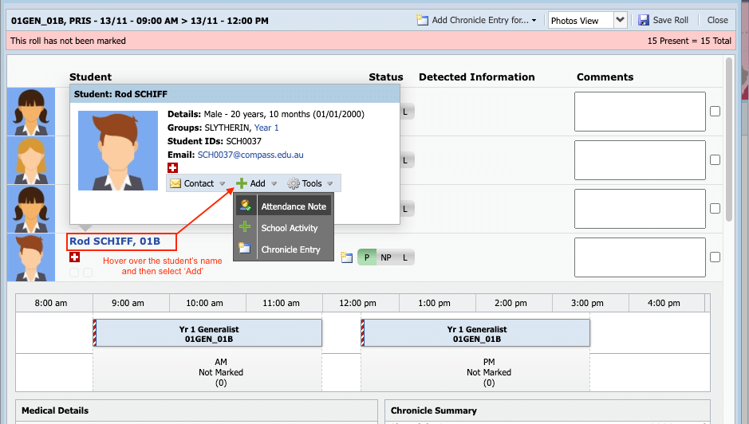

Complete the form:
- Select Reason
- Add Comments (if applicable)
- Set the Date Range
- Upload Attachments (e.g. medical certificates)
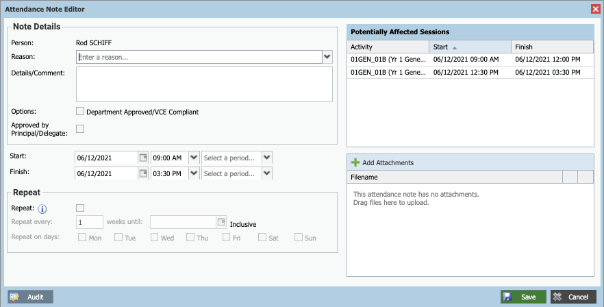
- Click Save

