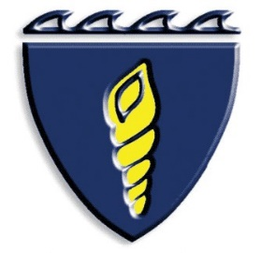
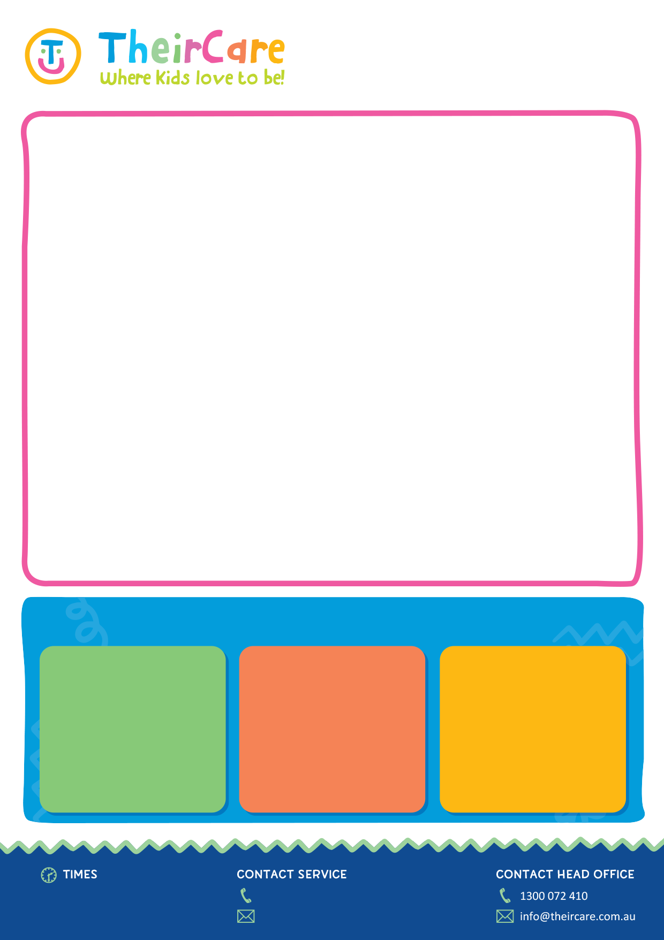
This term we have focused on a wide range of topics such as learning new languages, making 3D shapes out of paper, Using our marble run and magnatiles to challenge our STEM brains. We have also been focusing on social awareness and building safe and positive relationships with friends. We have done an large range of craft and painting activities where we experiment with using different textures and materials in our work.
We are so proud of all our kiddos and watching them continue to grow and support them has been a blessing
What have we been up to?
As I am sure many of you are already aware, next Friday is crazy hair day at Kapinara, I wanted to reach out to you all and extend my help, I know the mornings can often be a mad dash out the door and I don’t want any little ones missing out. If your child is interested in having a super funky / specific hairstyle please feel free to book them into BSC on that day. I will be equipped with all things from braiding skills, Hair glitter and coloured spray and cooky hair stickers.

Friday 20th September
Hello to all of our wonderful families, We hope you have been having a fabulous school term so far and are looking forward to the school holidays.

We have so many exciting activities planned these holidays such as challenging your inner Ninja Warrior Skills at the Osborne Park Ninja academy, a day out at the zoo and the cinema and many more exciting adventures. Book in now to secure your place!
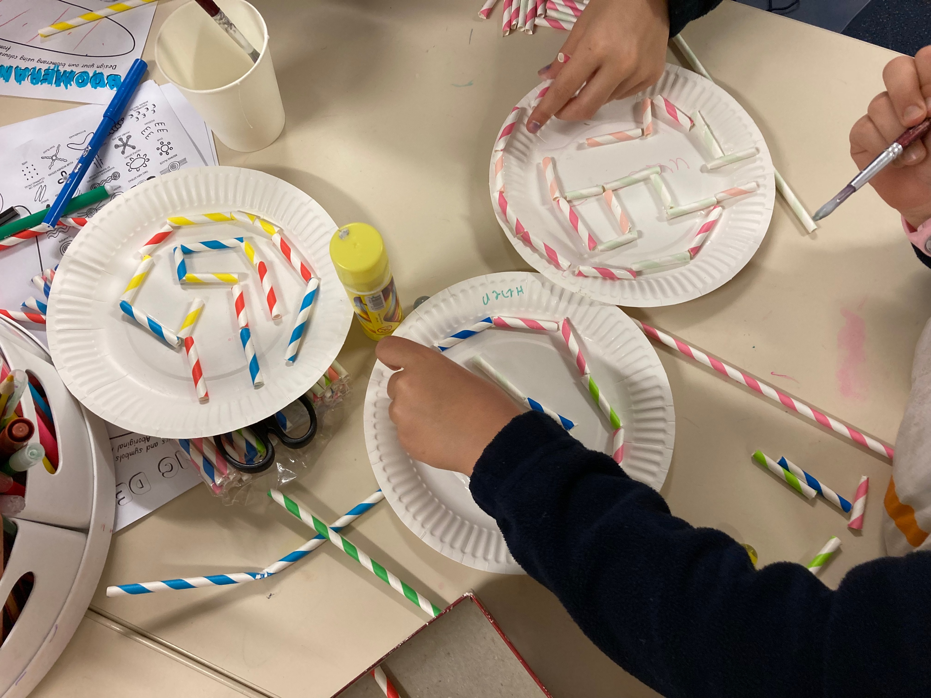
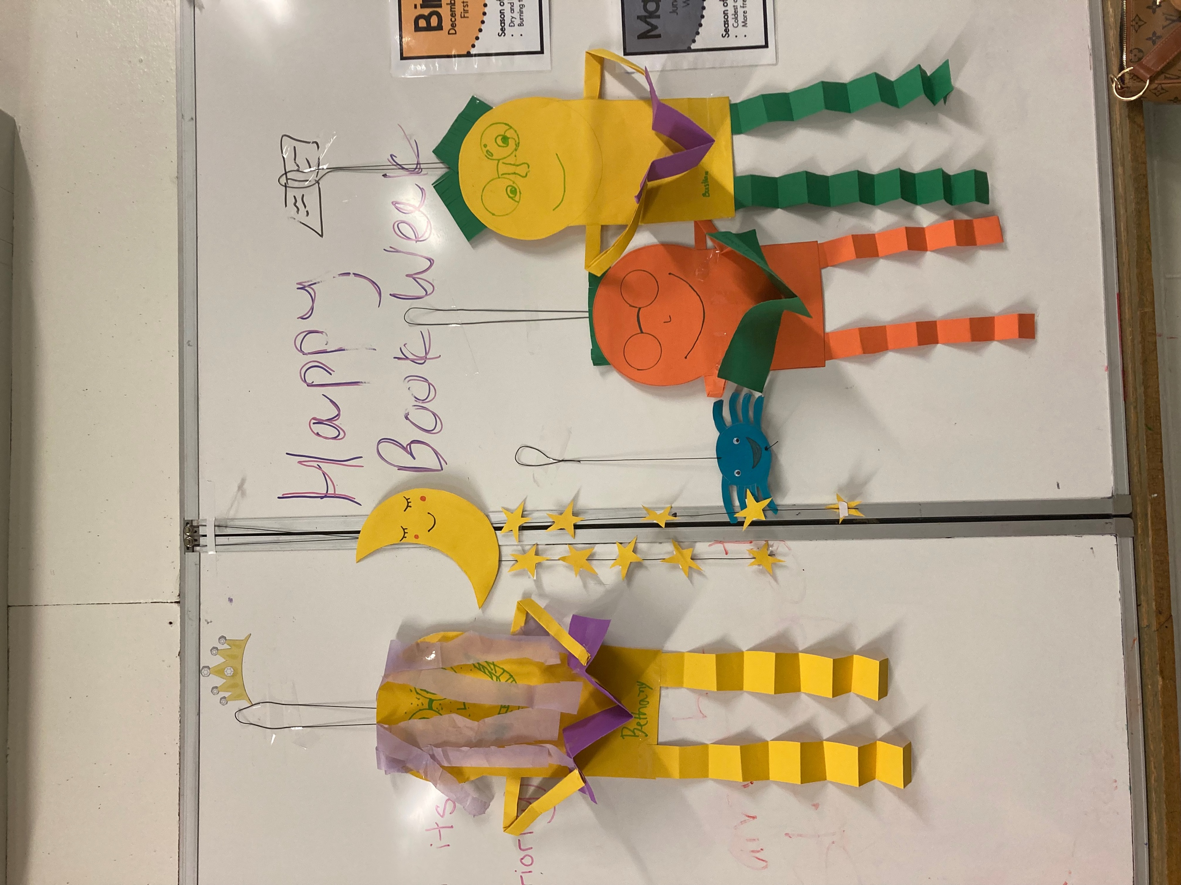
Place text here
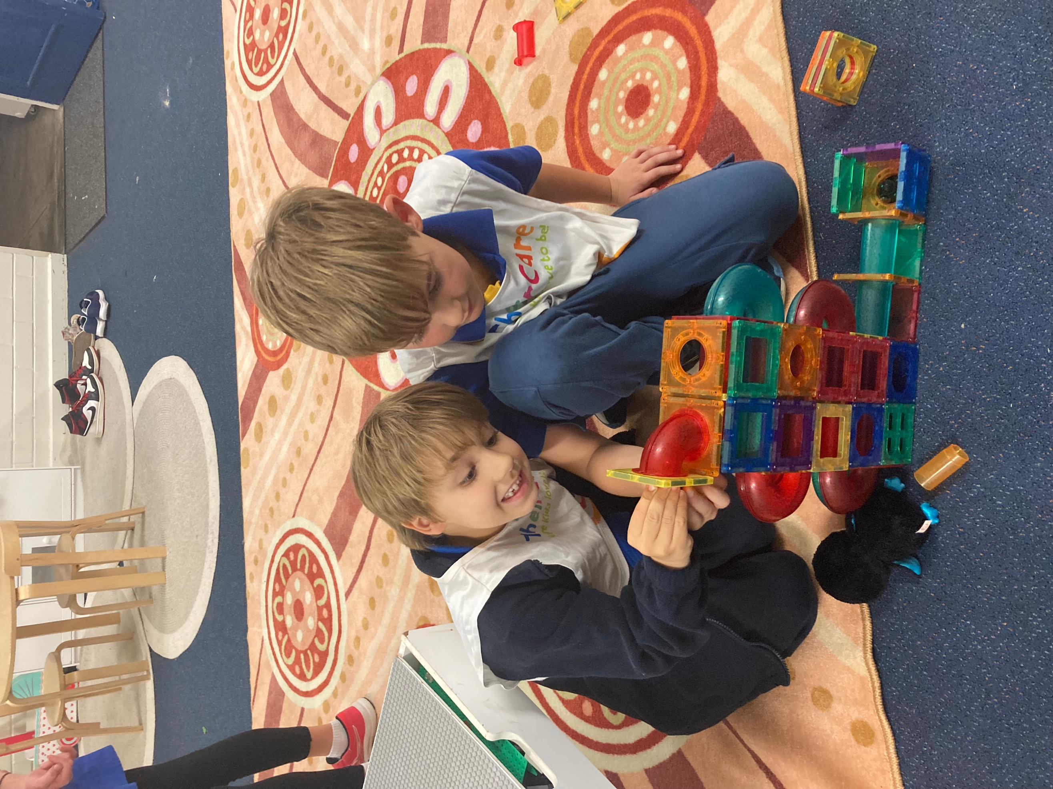

Kapinara Week 8 Newsletter
Creative Captures
Before school: [6:30– 8:45] AM
After school: [3:00 – 6:00] PM
[0499 305 116]
kapinara@theircare.com.au

