
KAPINARA PRIMARY SCHOOL
Catesby Street, City Beach WA 6015
Ph: 9237 7450
www.kapinaraps.wa.edu.au

Dear Parents and Carers

Re: Year 4-6 Faction Swimming Carnival 2023

Date of excursion: Tuesday 7 March 2023
Transport: Bus with seatbelts, traveling in class groups
Venue: Bold Park Aquatic Centre,
215 The Boulevard, City Beach, 6015
Students arrive at school | 8.45 am, go straight to class and have name marked off roll
Bus departs Kapinara | 9.10 am
Carnival commences | 9.30 am (approx.)
Bus departs Bold Park Aquatic Centre | 1.00 pm – returning for lunch
Staff member responsible for First Aid | Kathryn Scott
Supervision arrangements | 1 adult per 10 students

Clothing requirements: Swimming bathers, cap (provided on day), towel, faction shirt, hat, change of clothes, goggles (strongly advised) and sunscreen. As we are using the outdoor pool, sunscreen is essential. There is no requirement to a wear a rash shirt while swimming but students must wear a shirt and hat when sitting in bays.

Day arrangements: Students are to arrive at school with a towel and wearing their bathers with shorts, with their faction shirt over the top (labelled please) and slip-on shoes. Students also need to bring their full school uniform (including underwear and enclosed shoes) for the remainder of the day.

Eating arrangements: Students need to bring healthy snacks for recess (no lollies please) and a water bottle. Students will have a late lunch on their return to school.

Spectators: Parents are invited to the event, the spectator fee at the venue is $4.00. Spectators are to sit in the west stand and not in the area at the shallow end where the races will be finishing. Spectators are advised to bring something comfortable to sit on. Spectators must remain in the designated area, and not enter the bays at any time, this helps ensure student safety and supervision at all times.

Bus cost and pool entry: $11.00
Payment and permission is now available through Qkr due by 3 of March, 2023.

CARNIVAL PROGRAM: (subject to change)

50m Freestyle years 4-6
50m Breaststroke years 4-6
50m Backstroke years 4-6
25m Freestyle years 4-6
25m Breaststroke years 4-6
25m Backstroke years 4-6
50m Butterfly years 4-6
Super mix Relay 4-6 (300m)
Novelty event (time permitting)

KAPINARA PRIMARY SCHOOL
Catesby Street, City Beach WA 6015
Ph: 9237 7450
www.kapinaraps.wa.edu.au

CONSENT FORM

PERMISSION NOTE TO RETURN ONLY IF NOT USING QKR

EXCURSION TO: Faction Swimming Carnival at Bold Park Aquatic Centre

I have read and understood the information regarding the excursion to Bold Park Aquatic Centre and verify the confidential details relating to my child’s address, telephone number, and doctor, medical details, allergies and medication are unchanged from the information provided to the school. If your child’s medical condition has changed, or your child has special needs, please contact the school.

Special Considerations: If the proposed excursion poses any health risks in addition to those identified in the Student Health Care Summary provided to the school, please outline additional contextual health risks below:

I consent to ___________________________________________ in Year ____________
participating in this excursion on Tuesday 7 March 2023, and I understand that transport will be to the venue by bus with seatbelts. I am aware that the school and its employees are not responsible for personal injuries or property damage which may occur on an excursion unless the school or its employees are proven to be negligent.

Where it is not practical to communicate with me, I authorise the teacher in charge of the excursion to consent to my child receiving medical treatment as may be considered necessary. I am aware that the Department of Education insurance does not cover personal accidents through misadventure nor loss of personal belongings.

I am aware that inappropriate/unsafe behaviour whilst on an excursion may result in my child being asked to leave the excursion. Parents/Carers will be responsible for the collection of their child in the event of a student being asked to leave.
I consent to _____________________________________________ Class _______________

Parent signature________________________________________________ Date_____________

Kind regards,
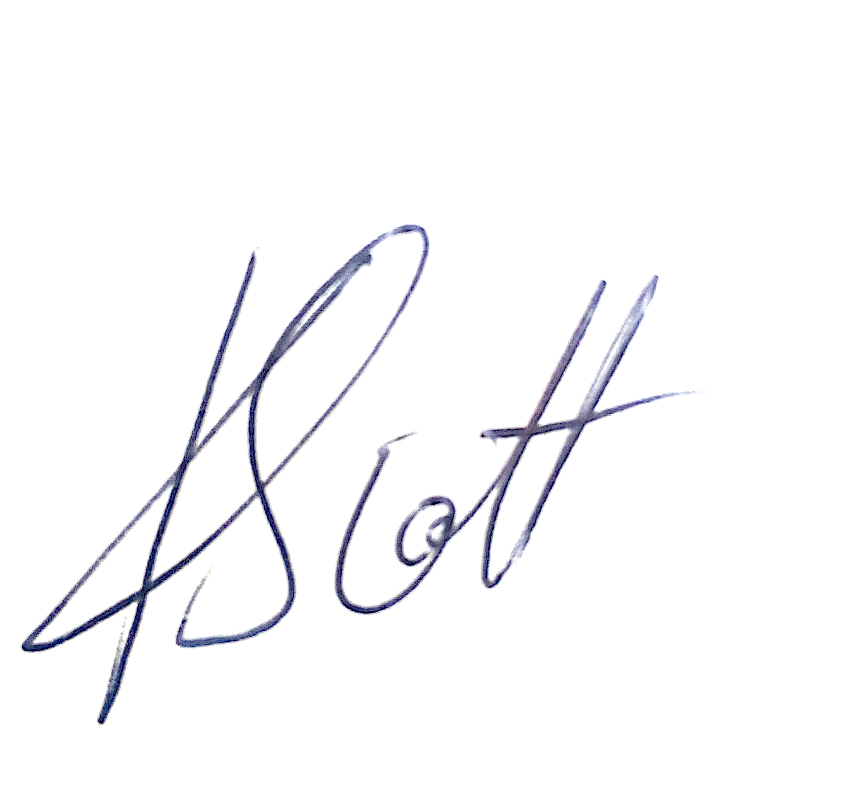
Kathryn Scott,
Physical Education Specialist Teacher

